StartBezier USER GUIDE

1.Component
Add this component to the game object you want to move .
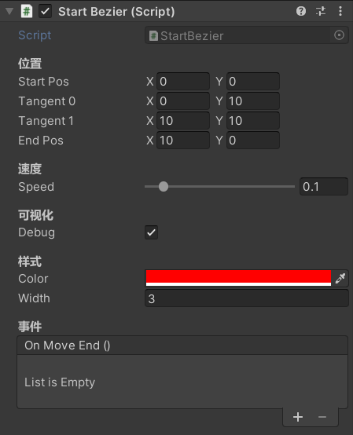

2.Position
Edit the Bezier curve, the curve has four positions, namely the start position, the first tangent, the second tangent, and the end position. In the Scene view, drag the handle with the mouse to complete the editing of the curve.

3.Speed
This item edits the speed at which the object moves on the Bezier curve.

4.Debug
This will visualize the mechanics of Bezier curves, such as linear interpolation moving in real time.
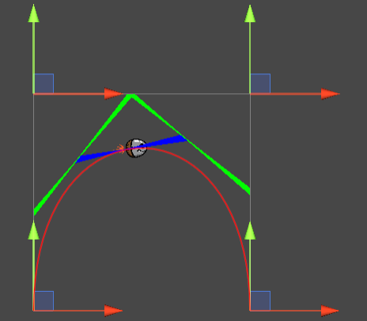

5.Curve style
Change the style of the curve, such as the color and width of the curve.
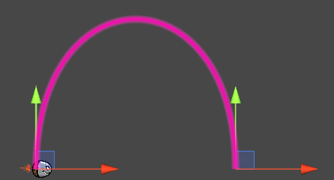

6.Event
Add event that will be called once after the object has finished moving.

7.Move with bezier curves
Congratulations, you have completed the entire edit, run the scene, and your objects will move on the Bezier curve, completing the elegant curve motion.

